Interview with Crippen by Ken Lumb

This article is an interview with the cartoonist Dave Lupton, who uses the name "Crippen" for his cartoons.

Ken Lumb, the editor of this issue of 'Coalition' magazine, asks Dave questions about his cartoons and Dave answers them.

Ken asks Dave when and how he first learned to draw.

Dave says that he started drawing cartoons when he was 9 or 10 years old, when he was off school because he was ill.

He says he also drew cartoons of his teachers when he was at school.

Sometimes his cartoons got him in trouble with the teachers, but the other children liked them.

Ken asks Dave why he chose to become a cartoonist instead of doing other kinds of art.

Dave says he chose to do cartoons because he did not like doing what he was told.

His teachers wanted him to do 'serious' art - like paintings or sculpture.

He felt like they only wanted him to do 'serious' art because it would make them look good as teachers.

He wanted to do something that was for himself, not for them.

His drawings became more like cartoons, until he felt like that was the only kind of drawing he could do or wanted to do.

Ken asks Dave when he started to do cartoons about disability, and why.

Dave says that he used a wheelchair for a while after he was in a car accident.

This made him realise how badly disabled people are treated by non-disabled people.

So he started to draw cartoons about how non-disabled people treated him.

Then he met other disabled people and learned about the social model of disability.

He started to get into the Disabled People's Movement and to do cartoons for and about it.

That was when he started calling himself 'Crippen'.

The name 'Crippen' is a joke on the word 'cripple', which is an old word for disabled people.

Most disabled people would be upset to be called a 'cripple'. But some disabled people have shortened the word to 'crip' and use it for themselves.

So by calling himself 'Crippen', Dave is saying he is proud to be a disabled person and that his cartoons and jokes are for disabled people.

Ken asks Dave why he thinks there are not many people doing cartoons in the Disabled People's Movement.

Dave says he is not sure why. But he thinks it might be because cartoons can make people get angry.

Some people might be scared to do cartoons because other people might be upset by them.

Dave says he enjoys it when charities get angry at his cartoons. But some disabled people might not enjoy that,

Dave also says that there are other disabled people who do cartoons, but not many people know about them.

He mentions two other disabled cartoonists called Steve Cribb and Eddie Freeman.

Ken asks Dave whether any of his cartoons have caused controversy.

Controversy is when people disagree about something and get angry or upset by it.

Then lots of people end up talking and arguing about it.

Dave says he hopes so, because this is what he wants his cartoons to do.

He mentions two of his cartoons that caused controversy.

One of them was about a group for disabled people that was run by non-disabled people.

Because his cartoon made the non-disabled managers of the group look bad, they threatened to take him to court.

They never actually did take him to court, and he does not say exactly what they said he had done that was bad enough for that.

But after this, lots of the disabled people in the group left and started a new group instead.

The new group was run by disabled people.

Dave says he likes to think that he helped that to happen.

The second cartoon that people got upset about was one that Dave did when Ian Stanton died.

Ian Stanton was a singer and activist who was quite famous in the Disabled People's Movement. He used a wheelchair.

He was a member of GMCDP. He edited a lot of issues of Coalition magazine, and wrote a lot of articles and reviews for it.

The cartoon showed Ian Stanton and other disabled people not being able to get into heaven because there were stairs to get in.

When the cartoon was published, some religious people were upset about it.

Dave says that his cartoons have also upset lots of charities and political parties.

Ken asks Dave what his favourite cartoon is.

Dave says it is one by a cartoonist called Steve Bell, who did cartoons for the Guardian newspaper.

The Guardian is a newspaper that comes out every day. It used to be famous for having funny cartoons that made fun of politicians.

But if Ken meant to ask Dave which of his own cartoons is his favourite, he says it is one that he did recently.

It is about disabled painters who paint using their mouths or their feet instead of their hands.

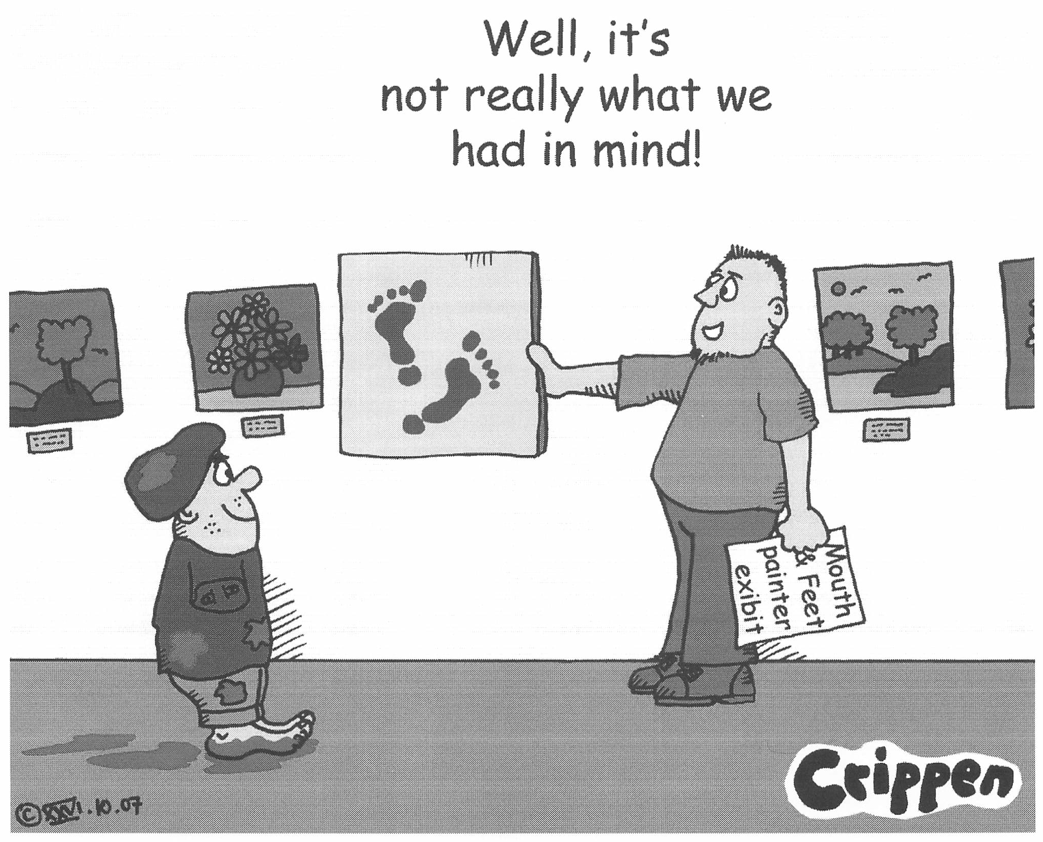

Ken asks Dave what he is working on now.

Dave says he is making some new cartoons, and he is putting together some of his older cartoons on his website.

He is also doing cartoons for the Disability Arts Online website.

Ken asks Dave what he thinks he will be doing 10 years from now.

Dave says he hopes he will still be making cartoons that show people about the ways that disabled people are treated unfairly.

But he jokes that people have told him that his signature has been getting bigger and bigger on his cartoons.

So maybe in 10 years his cartoons will only be his signature!



