BCODP Day of Action report

This article is about a march that was organised in London by the British Council of Organisations of Disabled People (BCODP).

The original version of the article was published in the November 1988 issue of Coalition magazine.

You can find all the articles from the November 1988 issue of Coalition magazine here[link]

It does not say in the magazine who wrote the article.

The British Council of Organisations of Disabled People (BCODP) was a group of disabled people's organisations (DPOs) from all over Britain.

The march was about a new law called the Social Security Act.

This law meant that a lot of disabled people would get less money to pay for the things that they needed.

Lots of disabled people were scared and angry about the new law.

Over 1,200 disabled people came to London from all over the country to join the march.

Before the march everyone met in a park called Kennington Park.

There were speeches in the park by two Members of Parliament (MPs), Jack Ashley and Alf Morris, and by Colin Low from the National Federation of the Blind.

The two MPs said that they were very angry at how disabled people were being treated.

They said they would tell everyone in the House of Commons about it that afternoon.

The House of Commons is one of the two Houses of Parliament.

It is where all the MPs vote on new laws.

Lots of disabled people from DPOs also spoke in the park.

John Evans was one. He was the Deputy Chair of BCODP.

He said that the march was not just for the disabled people who could get there, but also for all the disabled people who could not.

Lots of disabled people could not afford to travel to London, or they could not get there because public transport was not accessible.

But they still wanted to be there and to support it.

Lucille Lyden was another speaker. She worked for the Islington Disablement Association. This was a DPO in Islington, which is a part of London.

She said disabled people should not leave it to politicians to decide what happens to us.

We need to change things for ourselves, so we need to keep doing things like this march.

There were lots of people filming and taking photos for newspapers and TV news when everyone was in the park.

Lots of people brought banners. Everyone was excited to be going on the march.

But when the march started, there were not many people watching.

There were some builders working, who said they supported the march.

And there were a few people in cars. People were able to give some of them leaflets saying what the march was about.

But it was a bit disappointing that there were not lots of people.

The organisers had decided where the march would go so that it would get in the way of lots of cars, so that more people would notice it.

But the police were good at stopping the march from bothering many people.

The march was going to a place called Alexander Fleming House.

This was the offices of the Department for Health and Social Security (DHSS).

Social Security means things that support people with things they need, such as money for people who have no jobs.

The DHSS was in charge of these things, as well as health services, like doctors and hospitals.

Some disabled people from BCODP were supposed to be giving a letter to Nicholas Scott.

He was the Minister for the Disabled.

This means he was the MP in the government whose job was to decide on things for disabled people.

The letter from BCODP was about how worried they were about the Social Security Act and what it would do to disabled people.

But when they got to Alexander Fleming House, Nicholas Scott was not there.

He did not want to talk to BCODP or to take their letter.

The government said this was because they were changing how their departments worked.

The government had decided to split the DHSS into two, so that Health and Social Security would be two separate departments.

There would be two new Ministers, one for Health and one for Social Security.

So Nicholas Scott was busy with sorting all of this out.

Someone else who worked for him took the letter.

Later, Nicholas Scott even said that what the BCODP had said in the letter was not true.

Lots of the disabled people on the march were angry about this.

So they decided to sit down in the road at a roundabout.

Some of them were a bit worried about doing this.

But they wanted to do it to show the government that disabled people were angry and would not accept what they were doing.

This was not something that the whole march had planned to do.

The people who did it just decided to do it at that moment/there and then.

So lots of people did not sit down with them and went back to the park instead.

There were marshals on the march.

A marshal is someone whose job is to show people where the march is going and to keep people going the right way.

One of the marshals tried to stop people sitting down and get them to keep moving like everyone else .

The police also wanted to stop people from sitting down and blocking the road.

So they asked the people who had been pushing people in wheelchairs to push them away.

These might have been people's PAs or other disabled people who were not wheelchair users.

They said they would not move the wheelchair users unless the wheelchair users told them to.

And the wheelchair users pretended not to understand what the police were saying.

The police talked about arresting people, but they did not really want to arrest lots of disabled people.

So in the end they went away and no one got arrested.

The people who sat down in the road eventually went back to the park. They felt like sitting down in the road had not really done anything.

After the march, everyone was tired and lots of people just wanted to go home.

Some people went to a disability arts event that was happening afterwards at an arts centre.

This was organised by the London Disability Arts Forum.

It was a cabaret event. This is an event when lots of different people perform on a stage.

They might be doing music or poetry or comedy or other performances.

Two of the people who performed at this one were Rikki Jodelco and Keith Armstrong.

They sang a blues song about charity that they improvised. This means they were making up the words and music as they went along.

The people from GMCDP who went really enjoyed this. They felt like it was a really important part of the event.

There are lots of photos with the article.

There is also a very short article about it from the Times newspaper.

This has two photos of disabled people on the march, smiling and looking happy.

These photos did not show any banners like the photos that disabled people took on the march.

They did not show disabled people shouting or being angry.

GMCDP think it is odd that the Times showed the march as people being happy with their friends and families.

It was really people who are very scared and angry about a cruel law that is taking money away from them.

The photos taken by disabled people show how it really was, but the photos in the Times do not.

One news reporter said that the march was not worth talking about in the news, because it happened too long after the law was passed.

But the BCODP had wanted to wait until they knew more about what was happening.

The government had said, before the law was passed, that they would not be taking money away from disabled people.

They said that they were waiting for the answers from a survey that they did.

A survey is a list of questions that someone like a researcher asks a lot of people.

They do this to find out what people think about something, or how many people are affected by something.

The government had got some researchers to do a survey of disabled people.

They were going to use the information from this survey to decide how much money and what other help disabled people should get.

So the BCODP did not know at first what the new law was going to do to disabled people.

They did not want to have a protest about something that they did not know enough about.

That could have made them look silly, like they were protesting for no good reason.

There are some good things that we know now because of this march.

We know that it is possible to get disabled people together from all over the country.

We know there are lots of disabled people who want to be active in the Disabled People's Movement.

We know that it does not cost a lot of money to organise a march like this.

Disabled people who do not have a DPO in their area will know about the Disabled People's Movement because of this march.

They will have seen it on TV or heard about it on the radio.

So they will know that there are other disabled people who are fighting for our rights and for the things that they need.

Hopefully this will mean more disabled people will join the movement in the future.

Photos from the article:

1) photograph of a group of disabled people, mainly wheelchair users, with placards and a banner saying "HCIL". Caption: "... protesters gathered in Kensington Park..."
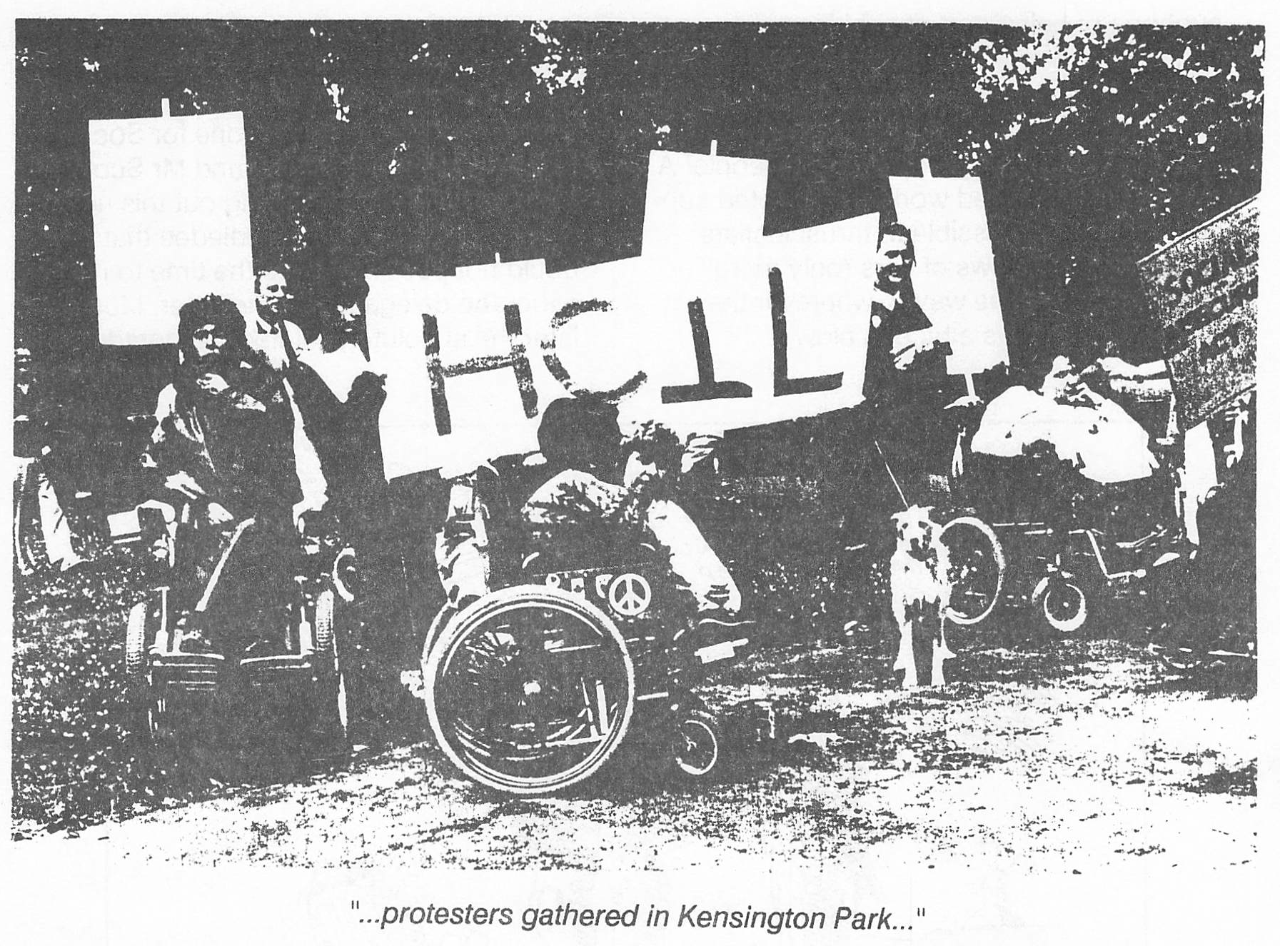

2) photograph of a person being pushed in a wheelchair in front of a line of uniformed police on a London street. Caption: "The police were a little anxious, but stoical."
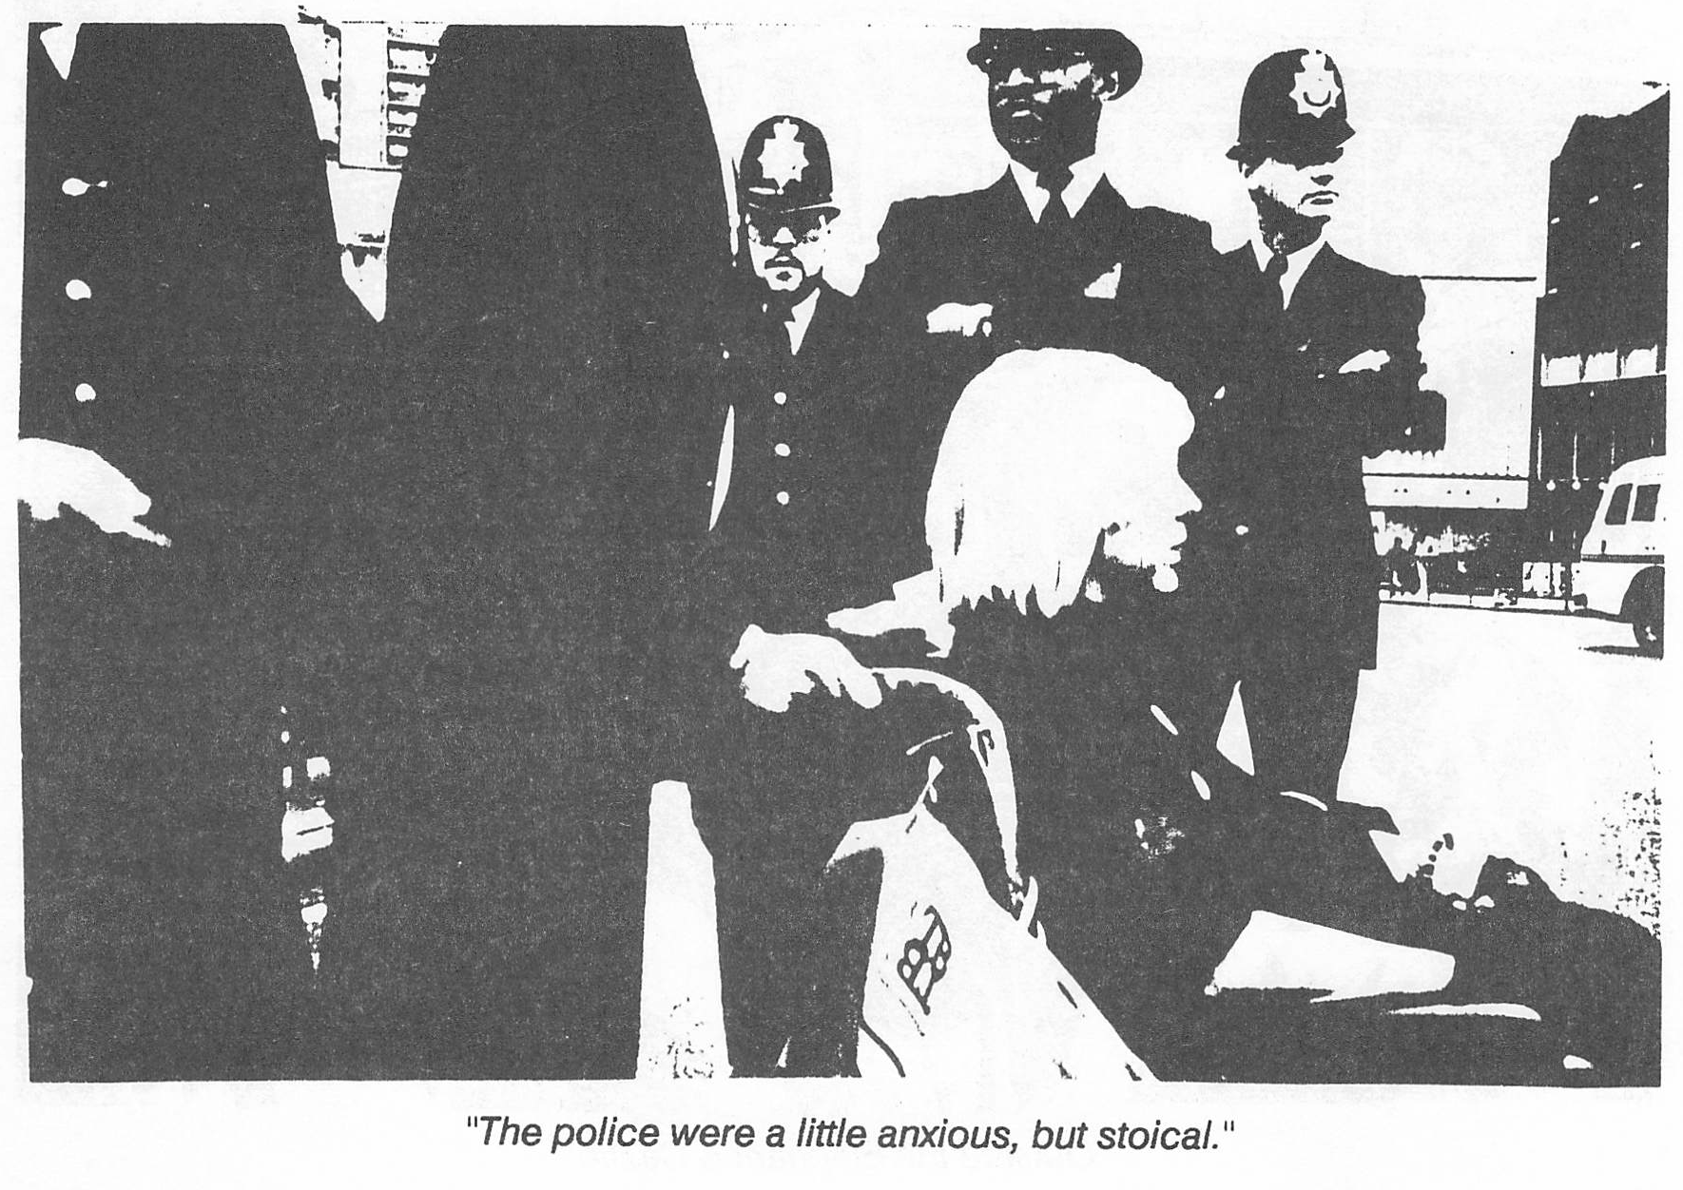
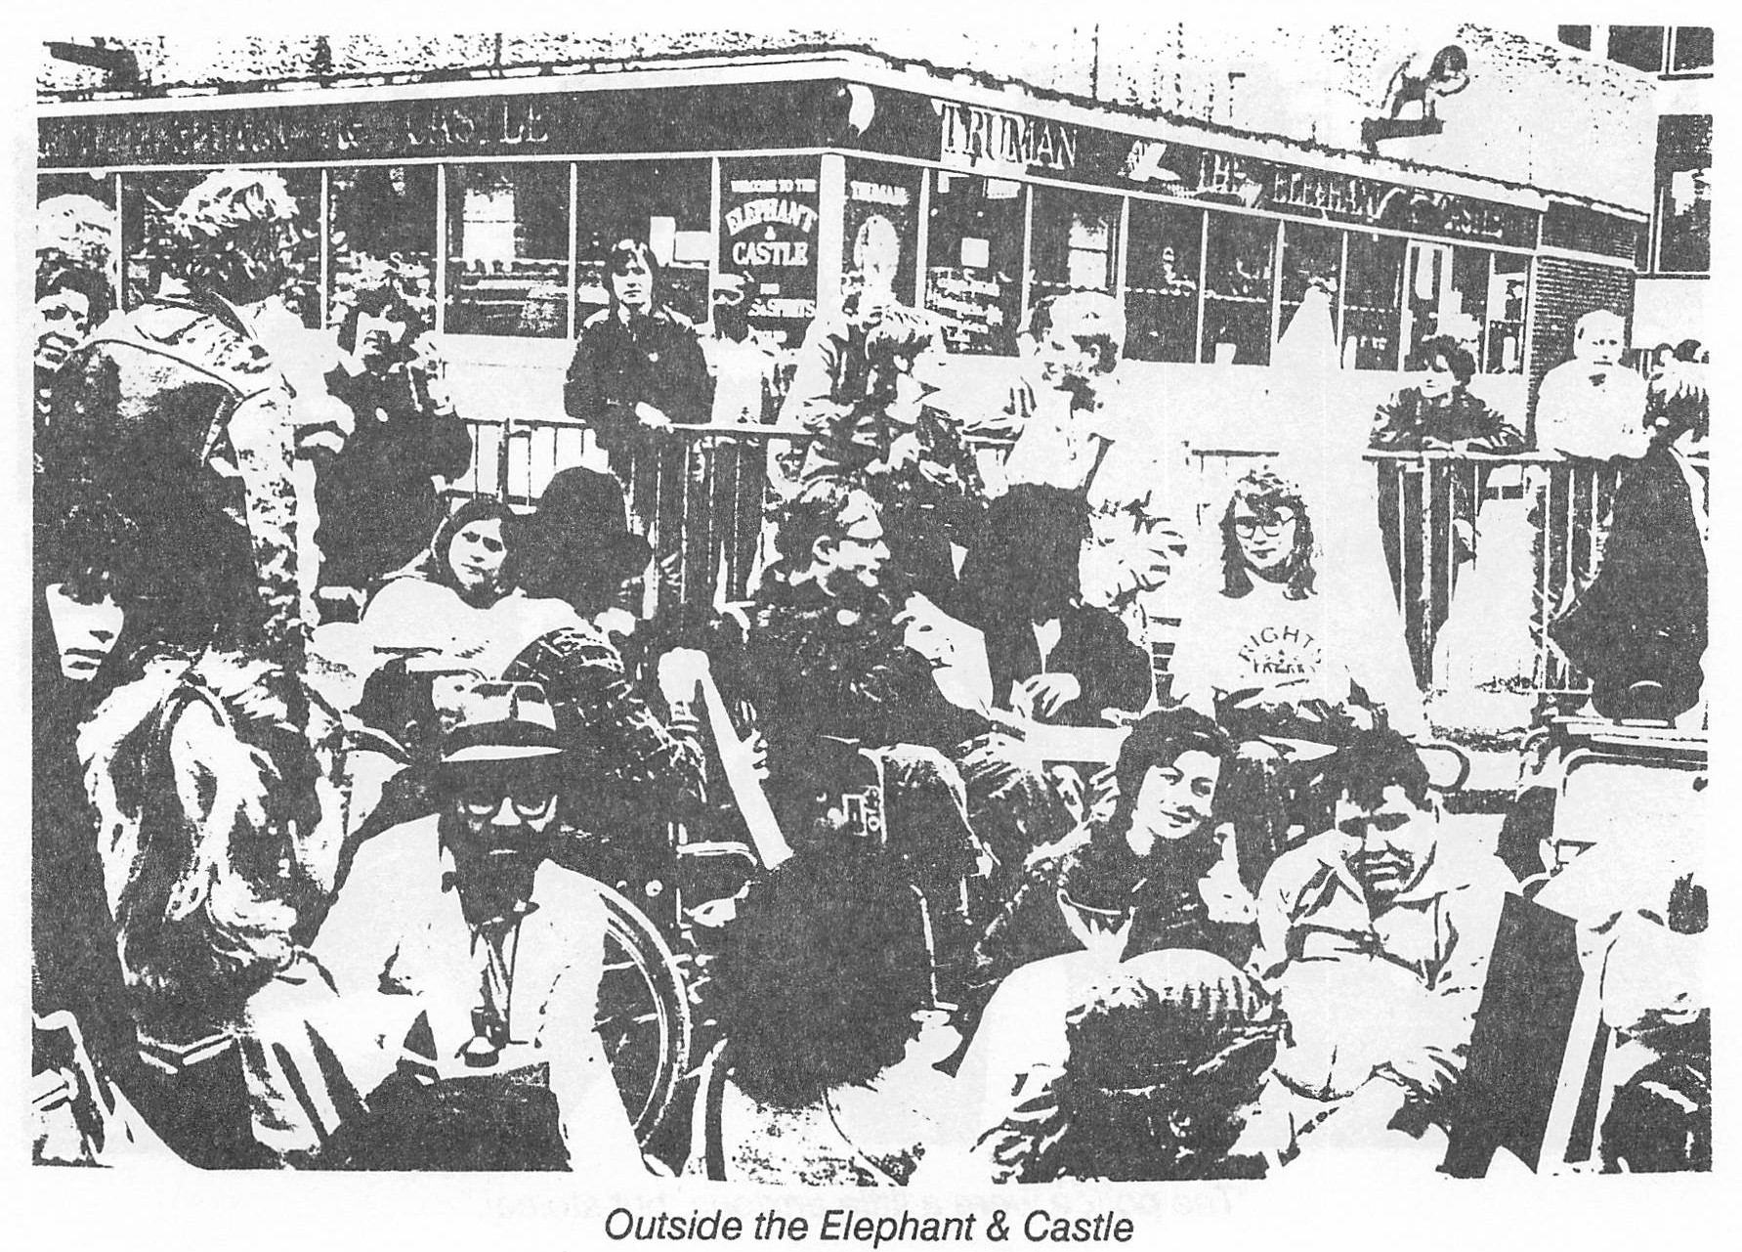
3) photograph of a large group of people including several wheelchair users and others sitting on the ground in a fenced-off street in front of a pub. Caption: "Outside the Elephant & Castle".
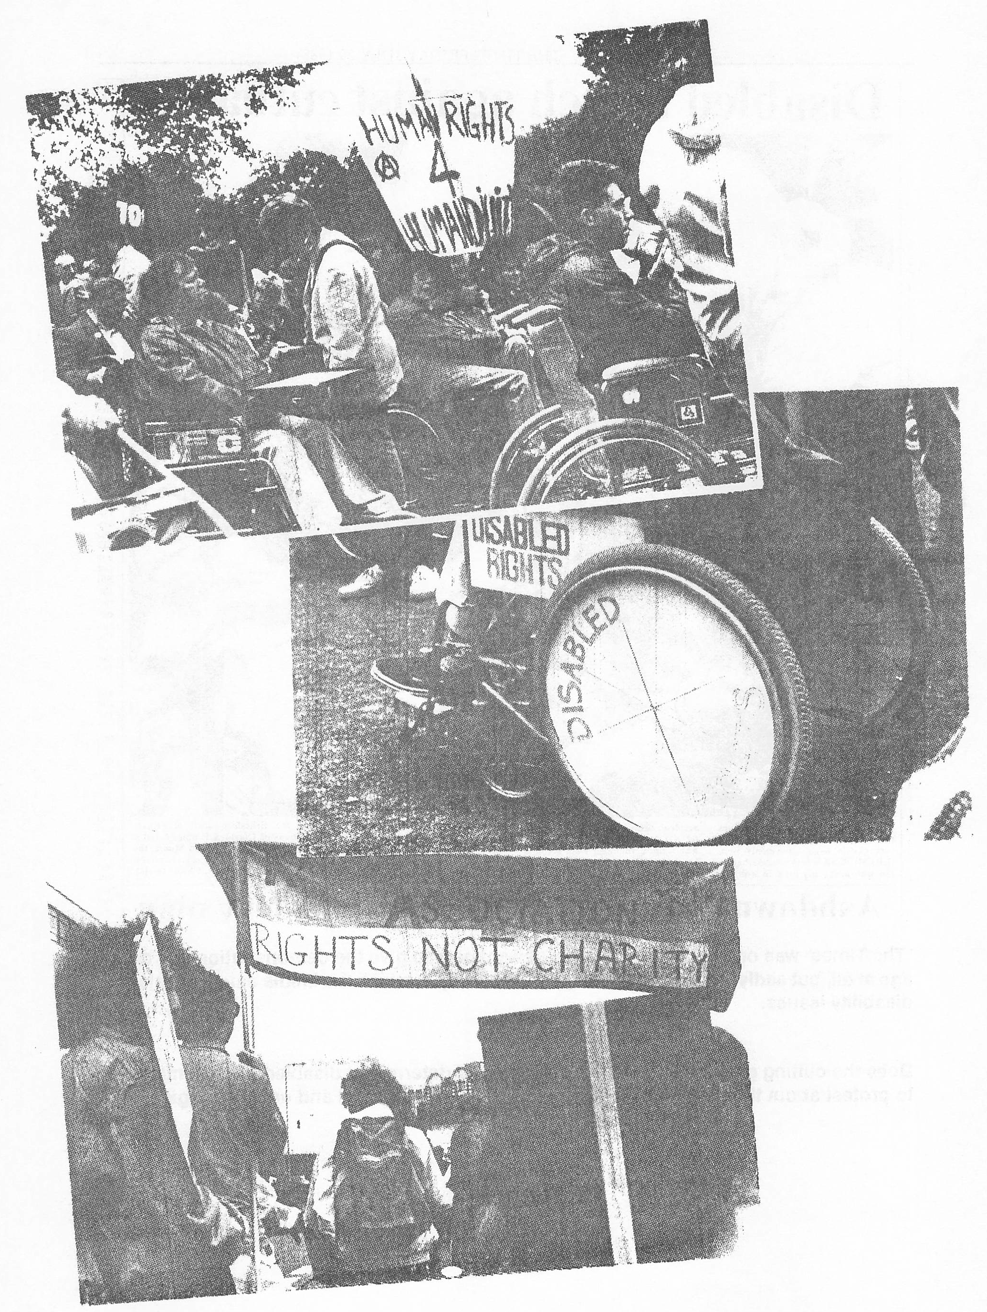
4) 3 photographs overlapping each other. 1: a group of disabled people with banners in a park. 2: a close-up of the lower part of a wheelchair with signs saying "Disabled Rights" on it. 3: people marching, seen from behind, with a banner saying "Rights Not Charity".
The newspaper article from The Times:

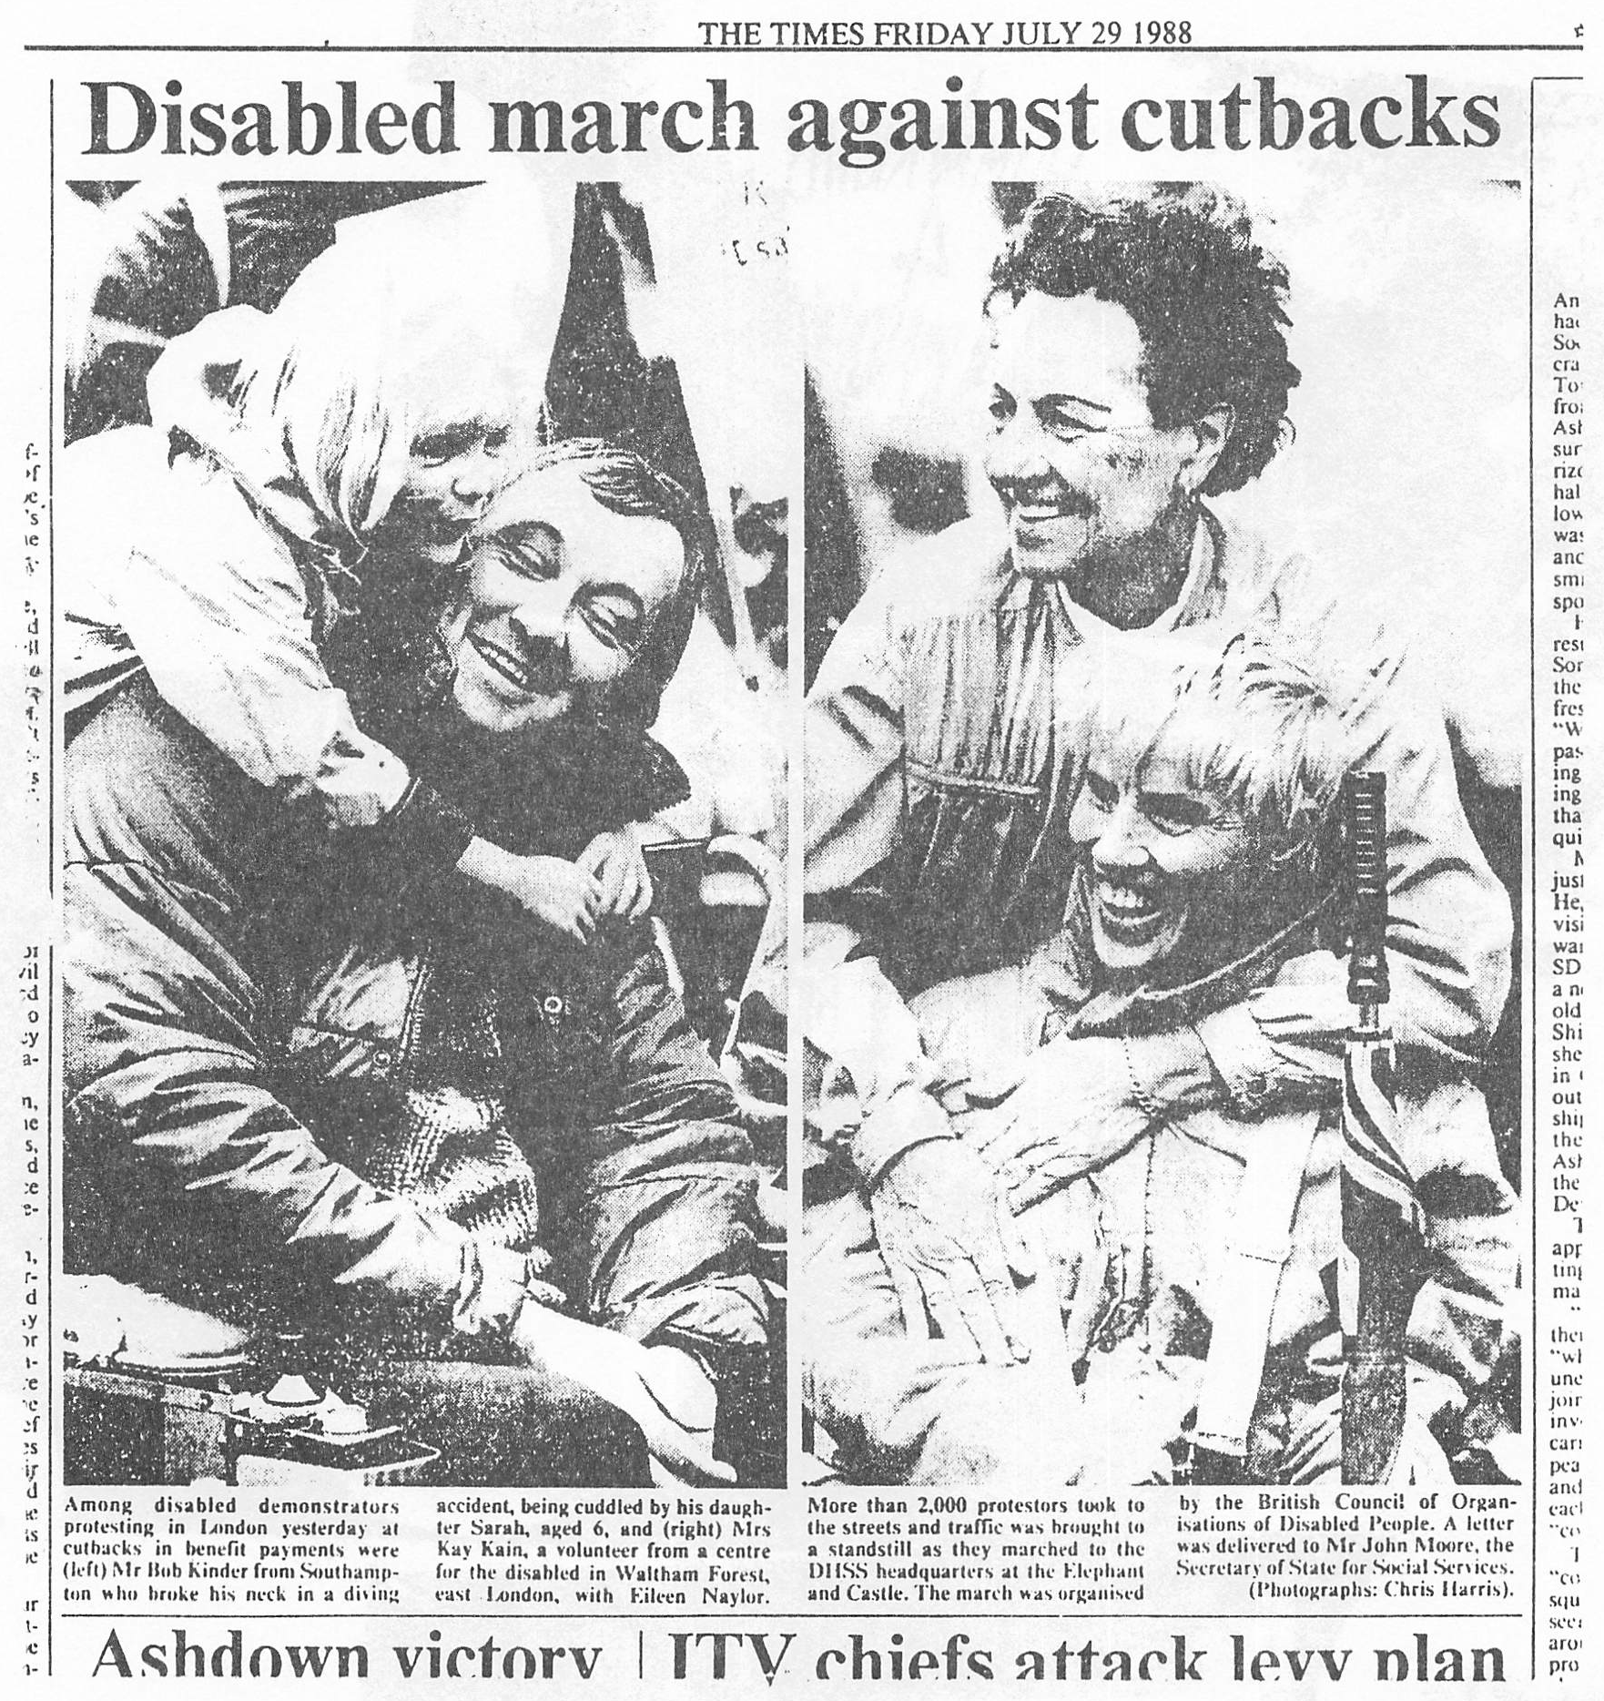
Original text of the Times article:

Disabled march against cutbacks

Among disabled demonstrators protesting in London yesterday at cutbacks in benefit payments were (left) Mr Rob Kinder from Southampton who broke his neck in a diving accident, being cuddled by his daughter Sarah, aged 6, and (right) Mrs Kay Kain, a volunteer from a centre for the disabled in Waltham Forest, east London, with Eileen Naylor. More than 2,000 protestors took to the streets and traffic was brought to a standstill as they marched to the DHSS headquarters at the Elephant and Castle. The march was organised by the British Council of Organisations of Disabled People. A letter was delivered to Mr John Moore, the Secretary of State for Social Services. (Photographs: Chris Harris.)

